Task 2
Moved all 4 files which were along the zip file downloaded from provided link; Did not know whether sample_submission was needed but still uploaded it. :)
Screenshots:
General overview of Directory:
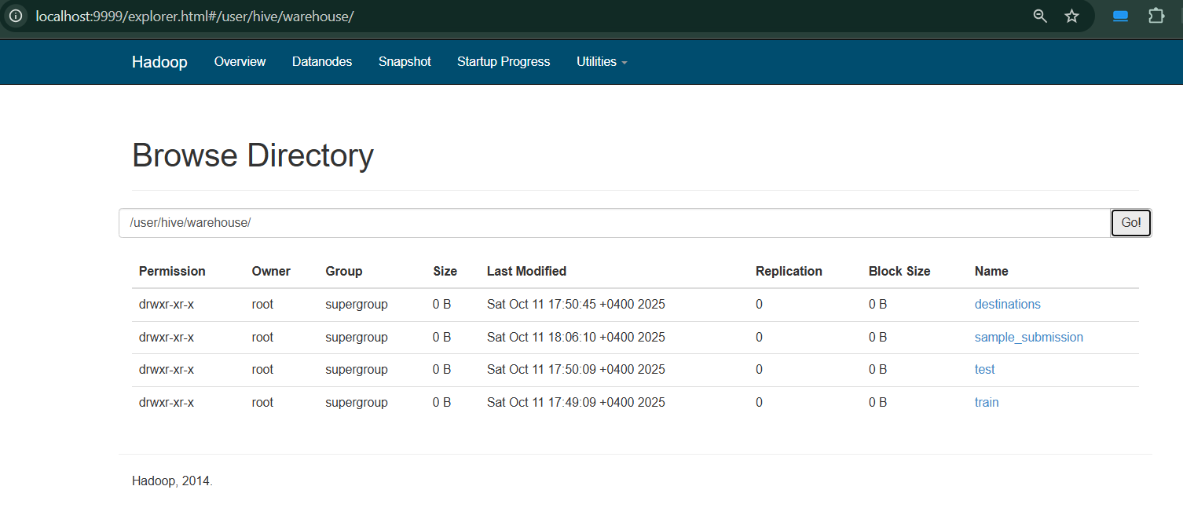
Destinations:
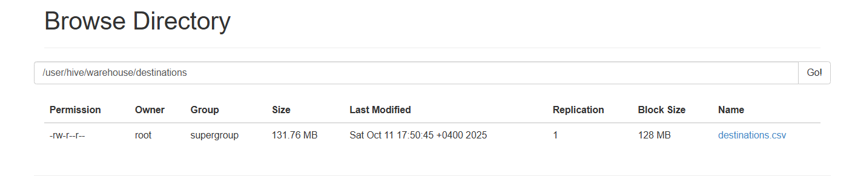
Test:
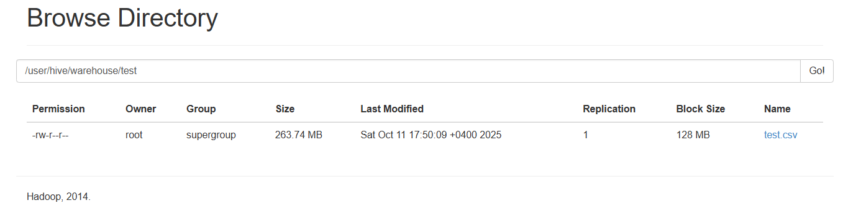
Train:
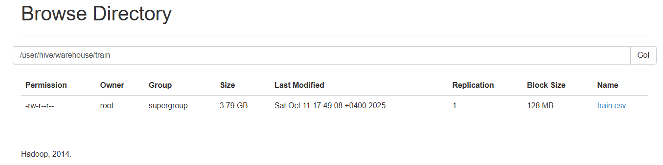
Sample_submission:
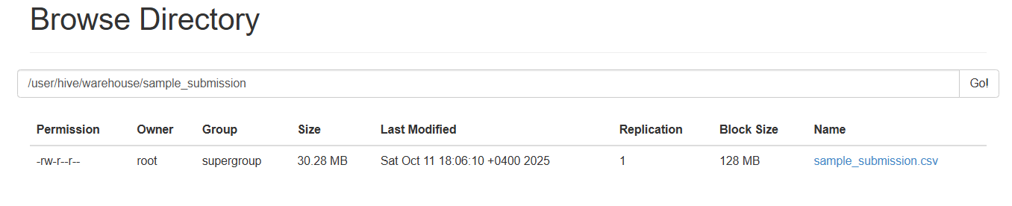
Example of bash commands used:
Task 3
For task 3 I turned csv into parquet via local python script, using the chunking method due to large size of train.csv. Even tested if memory was able to allocate all the needed space for train.csv but it failed. This way all the csv’s were turned into parquet and similarly as above sent to hdfs.
P.S. At the beginning I tried to run python in parallel container and take csv’s from the hdfs system and convert it from there. But in wain. I failed on the connection part, 8020 port refused to connect. Honestly, I don’t know the exact reason. Also maybe that was the way I should have done this task and not converted csv’s to parquet locally.
Task 4
The URL is not working, so I hope I took the correct screenshot of what was needed.

